Heavy Duty Truck/Off Road
Flexfab is a preferred supplier of silicone and other advanced elastomeric products to the Heavy Duty Truck and Off Road Equipment industries. Original Equipment Manufacturers rely on our engineering and design capabilities to solve even the most complex design challenges.

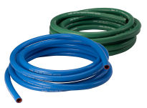

Silicone Heater Hose
- Green silicone heater hose
- Blue silicone heater hose

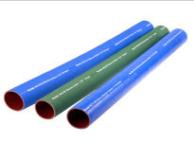

Silicone Coolant Hose
- 3-ply silicone coolant hose
- 4-ply silicone coolant hose
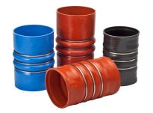

Charge Air
- Charge air bellows
- 4-ply hot side charge air hose
- 4-ply cold side charge air hose
- V-Band
- South American applications
- European applications
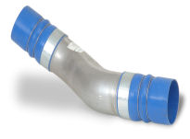

Crimped Assembly
Our crimped assembly includes complete silicone hose / pipe / hose unit, ready for assembly onto the engine. Custom designed for your application

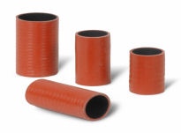

EGR Hose
EGR sensor hose are fluorocarbon-lined silicone exhaust gas recirculation (EGR) sleeves custom designed for EGR gas delivery.
- EGR Hose

Silicone Sleeves & Connectors
Flexfab’s silicone sleeves and connectors are used for Turbocharger connections on stationary equipment and on smaller engines; best suited for Construction and Agriculture applications that are less prone to offset and vibration where a bellows is needed.

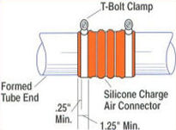

Clamping Instructions
A critical part of the sealing/clamping process is the proper position of the clamp onto the hose.
**
Follow your clamp supplier’s torque recommendatins for proper sealing
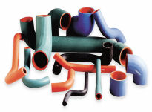

Formed Silicone Coolant Hose
Flexfab’s formed silicone hose are custom designed and manufactured for coolant transfer.
*
They are manufactured in fixed shapes for runs through specific paths on and around the engine.

